**Data manipulation language**

**Definition:**

1. Data Manipulation Language (DML) statements are used for managing data in database.
2. DML commands are not auto-committed.
3. It means changes made by DML command are not permanent to database, it can be rolled back.

**Commands in dml:**

1. INSERT
2. UPDATE
3. DELETE

**INSERT**

It inserts a record to a table.

**Syntax:**

Insert into table_Name

Values(v1,v2,v3…)

Or

Insert into table_Name (column1,column2,…)

Values (v1,v1,….)

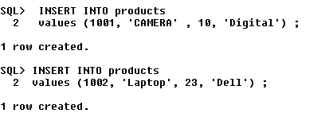

This is how we insert values into a table. All characters and alpha-numeric characters(ex – 10023sdf78) must be enclosed in single quotes (‘ ‘ ) and each value must be separated by comma. Also we must be careful in entering the data without violating the primary key, foreign key , unique constraints.

Now let us see the table in which the data in has been inserted,

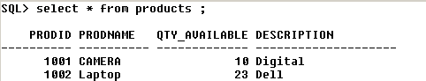

Now, let us insert data into the table **orders** in which a foreign key is referencing primary key,



Here, we see that 1001 is the same prodid as of the earlier table. Sysdate – it displays the current date set in the system .

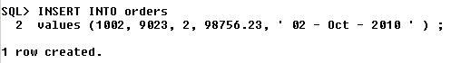

Now, let us see the table,

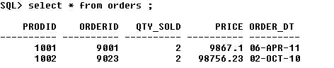

Another way of inserting data into the table is shown below,

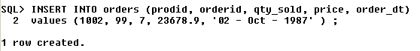

Now, let us see the table,

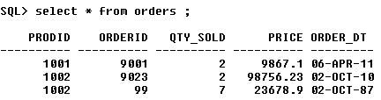

**UPDATE** :-

Update command is used to update one or more rows of a table.

**Syntax:**

**UPDATE** *table-name* set column-name = value

*where* **condition**;

**For ex – 1)** Let us update salary by increasing it by Rs200 and also give commission of Rs100 where empno = 7369.

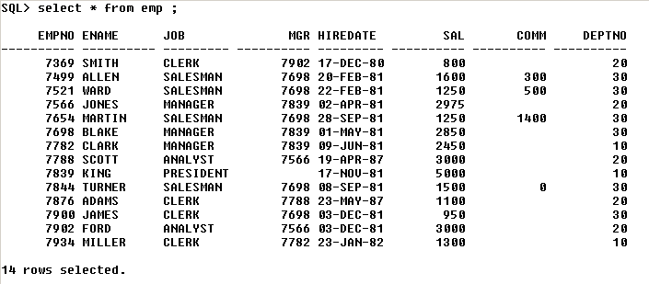

Now, let us **update** the said record as shown below,



Let us verify if the record has been updated,

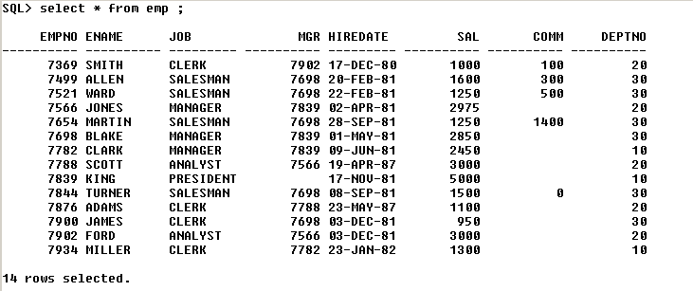

Thus, the record(empno – 7369) has been updated.

**DELETE**

Delete command is used to delete data from a table.

Delete command can also be used with condition to delete a particular row.

**Syntax:**

**DELETE** from *table-name*

*[Where Condition(s)]*;

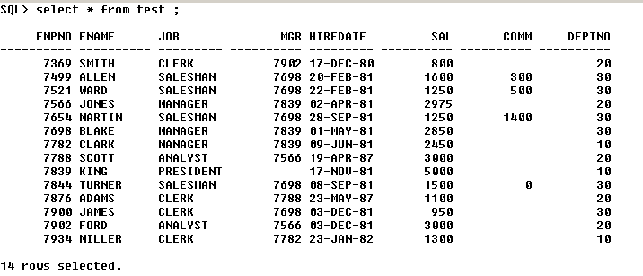

Thus, we have created the table test.



Thus 1 row, ‘miller’ has been deleted.

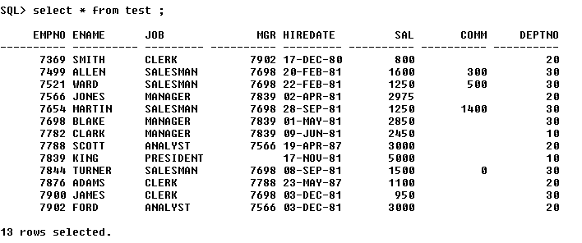

Thus, the deletion has been confirmed.